OPERATOR’S COMPLIANCE CHECKLIST: CAT.OP.MPA.160
Operator | Aircraft Type
*Note: S – Satisfactory | NS – Not Satisfactory | NA – Not Applicable
No | REQUIREMENT |  | DETAILS |  | MEANS OF COMPLIANCE OR REFERENCE |  | *S/NS/NA
1 | CAT.OP.MPA.160  Stowage of baggage and cargo |  | 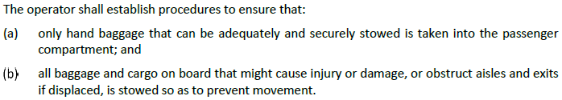
2 | AMC1 CAT.OP.MPA.160  Stowage of baggage and cargo |  | 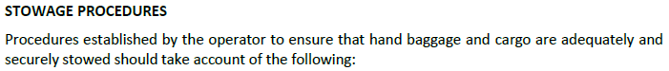
 |  |  | 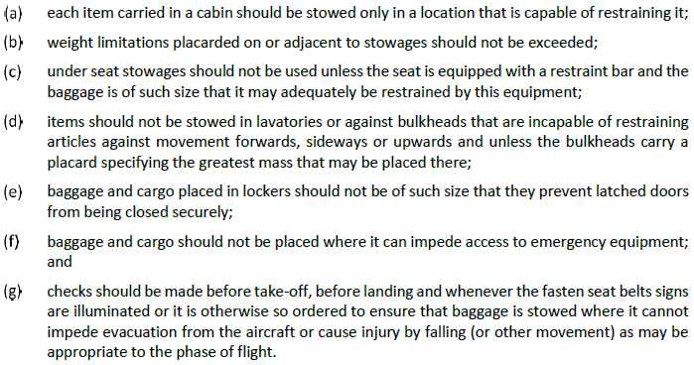
3 | AMC2 CAT.OP.MPA.160  Stowage of baggage and cargo
 |  |  | 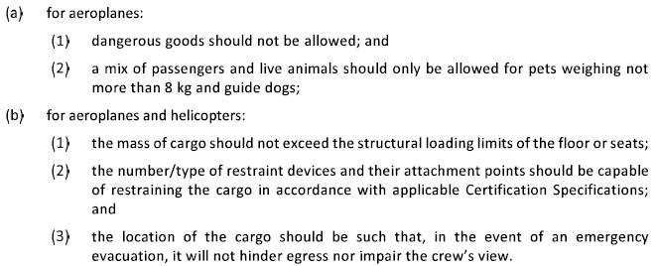
Inspector Comments / Remarks:
Reviewed by: |  | Name |  | Position |  | Date
Verified by: |  | Name |  | Position |  | Date

